Compensation Plan
IM Mastery Academy Compensation Plan & Full Pay Structure Breakdown
How Does IM Mastery Academy Compensation Plan Work?
This compensation plan is both simple to understand and pays out generously, let me show you below….
I will go into more detail in a moment but you basically have 3 legs that your pay plan consists of with unlimited depth of earning potential.
You want to structure your pay structure as even as possible because you will not be able to earn off of just one runaway leg with a ton of volume and the other 2 empty.
We have people working this company that has never made a dime online or with any other Network Marketing company making some incredible income with how this pay plan is structured and with the product that we offer.
The way it breaks down is that when you are able to sponsor just 12 people into your organization and have them balanced within 3 legs with no more than 40% of the commissionable volume coming from 1 leg, you will be making $600 per month!

How are the IM Mastery Academy Commissions Structured?
The compensation plan is structured as a unilevel compensation plan.
This means that all your personal referrals will be placed on your 1st level.
But with how this compensation plan is structured you will have a holding tank.
The holding tank basically holds your referrals for 10 days and you will also have the ability to place those personal referrals under people on your team.
So even though the commission plan is structured as a unilevel which is traditionally 1 level for all your personals you can actually stack them to just concentrate on a certain amount of legs of your choosing.
Now with that said, the compensation plan is structured in a way that when you are starting out you will want to concentrate on building only 3 legs.
Like I mentioned above you can earn $600 per month with just 12 people on your team in 3 legs whether they are your personals or referrals from one of your personal referrals or team members on those 3 legs.
Commission Plan Breakdown
There are 2 ways to join as a CUSTOMER or IBO, you can also do BOTH, but you will have huge advantages with where the compensation plan is concerned.
The first section of the Platinum Level would be…
The Platinum Bonus
The Platinum Bonus is paid weekly and is considered a fast start bonus when compared to most other MLM companies.
This is paid out when you refer people to this company and they upgrade to the Platinum Level.
These commissions are also paid out weekly.
So when you refer someone and they upgrade to the Platinum Level you earn a $25 commission payout, if they upgrade to Elite Level you earn $50,
So when you refer 10 at the Platinum Level you earn $250 and if you refer 10 at Elite level you earn $500 which will also be paid out weekly.
These bonus commissions are always nice for companies to include especially for those that pay to advertise so that you can get some type of return on your paid adverts.
Here is a chart to get a visual on the Platinum Bonus levels:
Weekly Residual Income
Unlike other companies, IM Mastery Academy pay out the residuals weekly!
IM Mastery Academy are the first company to bring weekly residual commission checks paid out to your bank account. They have been around for over 6 years building a strong reputation for fantastic products and lucrative compensation plan.
Your weekly residual will depend on your rank in the business.
The residuals consist of as little as $37.50 per week all the way to $125,000 per week depending on your rank qualification.
If you are a Platinum 150 you can be earning up to $150 per month or $37.50 per week.
For a Platinum 600, you can earn up to $600 per month or $150 per week.
This is the rank where when you sponsor just 12 people in 3 legs you will be earning $600 in commissions monthly which is a REALLY strong pay plan compared to ANY MLM company out on the market today.
Then the higher you go in rank the more money you can make per week.
I have included a compensation plan chart explaining the difference in levels of the commission pay structure you can earn when you reach certain ranks listed below.
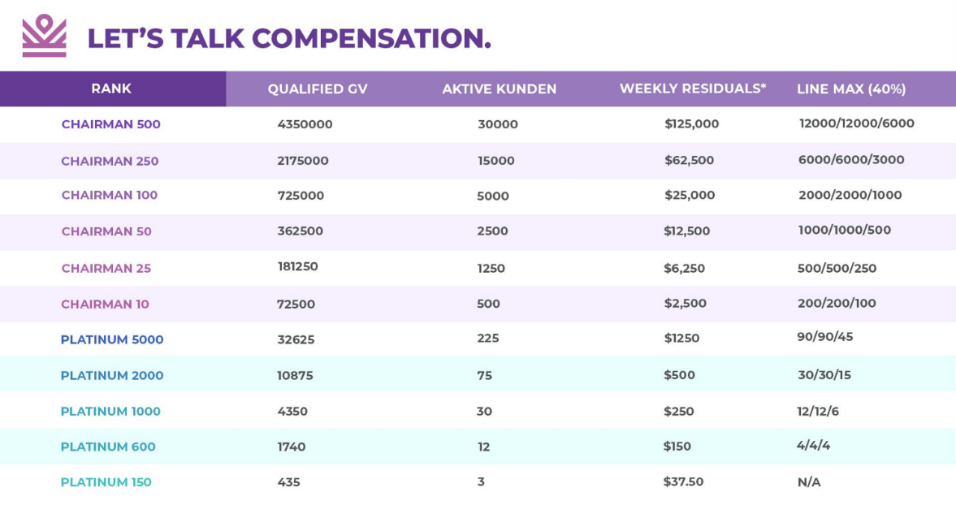
*Please Note… as long as you maintain your rank each week, you will get paid out the amount shown every week in commissions shown reflecting the chart I have included above.
So you see with just the IM Mastery Academy residual compensation plan part of it can really be life-changing income when you reach certain ranks.

Chairman Infinity Bonus
This is seen as the most powerful aspects of IM Mastery Academy compensation plan structure to earn money.
I will beg to differ simply because I feel that the residual income aspect yields a strong enough return upfront that keeps members happy with weekly payouts.
The fact that you don’t need too many personal referrals to earn a decent income.
As a matter of fact, you only need 2 referrals to break even with your monthly requirement!
But let’s break down this part of the compensation plan and you can be the judge.
These bonuses start when you hit the Chairman rank.
These bonus commissions are also paid out ON TOP of your residual commissions.
So basically, once you reach the rank of Chairman you will earn up to 2% of your total volume per leg down to the first matching rank.
So these percentages listed are per leg!
These are paid out down to total members also per leg unless there’s someone on that leg that has the same rank or higher than you.
In that case, that percentage will run down until it hits that person.
I’ve included a chart to include a visual understanding to help you understand this part of the commission plan.
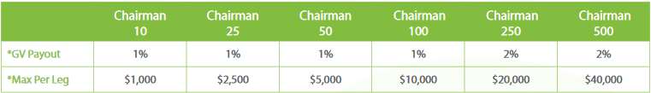
Also, these commissions represent a max that you can earn per qualifying rank that you reach, and also is paid “up to” those commissions listed.
Some of the payouts listed are:
Chairman 10, which pays 1% per leg and “up-to” $1000 per leg.
Chairman 25, which pays 1% per leg and “up-to” $2,500 per leg.
All the way up to Chairman 500, which pays 2% per leg and “up-to” $40,000 per leg!
Very substantial commissions can be earned here with this part of the compensation plan but it will take some work to get to these ranks, and for that reason alone is why I feel the residual commission part of the commission plan is where I feel it’s most powerful where people get excited to keep building and growing their teams to eventually get to the ranks listed here.

Rank Achievement Bonus
This bonus is a reward for staying in the business and staying committed to taking the time to build your business long-term and very large and strong.
The first half of these bonuses are paid out one time for reaching these ranks and maintaining them for 3 consecutive months.
And the other half will still need you to maintain the rank for 3 months BUT will be paid out for multiple months.
Now most companies that I’ve encountered only have a rank achievement bonus that pays out, but usually only one time.
I don’t think I have come across a Network Marketing company that pays out a rank advancement bonus for consecutive months and that is why this part of the commission plan is very lucrative, innovative, and is very strong.
I’ve included a chart below that illustrates the amount earned when you reach the qualifying ranks that qualify you for this bonus.
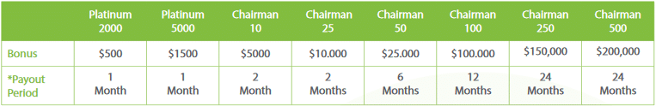
Rank Qualifications
This final section is about how to achieve the lucrative task of moving up in rank.
By moving up in rank you can see the income potential that is possible with how this commission structure is laid out.
This compensation plan is structured as a unilevel meaning that you can have unlimited legs… BUT to maximize this compensation plan it is best to only build 3 and you can do this due to the holding tank, which means that every new member that you personally sponsor will not be placed for a short amount of time until the system either places that member for you on your front line or when you manually place that member underneath another team member on any of your legs!
This is a really great tool for you to use to maximize this pay plan and help your team grow with downline members seeing momentum, and to help with recruiting leaders into the business as well.
Here is a list of the ranks and what you will need to do to qualify for each rank advancement:
**Note: You will need PSV (personal sponsored volume) and group or team overall volume to reach each ranking level which is illustrated on the chart, after Chairman 100 you will need additional ranking factors to hit the higher levels listed below. You cannot have any 1 leg producing 40% of all the group volume and there is also a customer rule as well (refer to chart).
There may be acronyms for certain verbiage of what is being explained below like PSV (personal sponsored volume) that you might not understand but I will include a guide below to explain what each one means.
- Starting Point A (IBO/Customer) –At this lower priced level you are qualified to participate in the compensation plan but you will not have access to the training or software. There is NO personal volume at this level that contributes to the compensation plan.
- Starting Point B (Platinum/Customer) –Simply join at the Platinum Level and have 0 personal members. (each Platinum Member on your team contributes to 150 PSV) You will have access to all the training and all the software.
- Platinum 150 –You are required to have 3 personally sponsored Platinum level referrals with a 435 PSV.
- Platinum 600 –You will need 12 Platinum members within 3 legs and a personal volume of 290 (at least 2 personals Platinum members) and a group volume of 1740 total, which includes your personal volume.
- Platinum 1000 –You will need 30 Platinum members within 3 legs and a personal volume of 290 (at least 2 personals Platinum members) which is the same as P600 but you will need a group volume of 4350 total, which also includes your personal volume.
- Platinum 2000 –You will need 75 Platinum members within 3 legs and a personal volume of 435 (at least 3 personals Platinum members) and a group volume of 10875 total, which includes your personal volume.
- Platinum 5000 –You will need 225 Platinum members within 3 legs and a personal volume of 435 (at least 3 personals Platinum members) and a group volume of 36625 total, which includes your personal volume.
- Chairman 10 –You will need 500 Platinum members within 3 legs and a personal volume of 435 PSV (at least 3 personals Platinum members) and a group volume of 72500 total, which includes your personal volume.
**Note: At the Chairman 25 Rank and above you will need additional requirements to qualify for these higher ranks in the form of having a certain amount of team members reaching a certain rank. (either your personally sponsored members or your downline members)
- Chairman 25 –You will need 1250 Platinum members within 3 legs and a personal volume of 435 PSV (at least 3 personals Platinum members) and a group volume of 18250 total, which includes your personal volume. (also needed: 2 “Platinum 2000” members within “2” different legs)
- Chairman 50 –You will need 2500 Platinum members within 3 legs and a personal volume of 435 PSV (at least 3 personals Platinum members) and a group volume of 362500 total, which includes your personal volume. (also needed: 1 “Platinum 2000” member and “1 Platinum 5000” member within “2” different legs)
- Chairman 100 –You will need 5000 Platinum members within 3 legs and a personal volume of 435 (at least 3 personals Platinum members) and a group volume of 725000 total, which includes your personal volume. (also needed: 2 “Chairman 10” members within “2” different legs)
- Chairman 250 – At this level, you will need 2500 Platinum members within 3 legs and a personal volume of 580 (at least 4 personals Platinum members) and a group volume of 2,175,000 total, which includes your personal volume. (also needed: 2 “Chairman 25” members within “2” different legs)
*Chairman 250’s will earn $250,000 per month in the Weekly Residual Income!
- Chairman 500 –At this level, you will need 2500 Platinum members within 3 legs and a personal volume of 580 (at least 4 personals Platinum members) and a group volume of 4,350,000 total, which includes your personal volume. (also needed: 2 “Chairman 50” members within “2” different legs)
*Chairman 500’s will earn $500,000 per month in the Weekly Residual Income!
What’s The Cost To Join IM Mastery Academy?
When you are ready to join IM Mastery Academy there are 2 options that you will have when you join.
I will give you a brief overview of both the cost and what it entails.
- If you join as an IBO, the cost is $16.71 with a monthly renewal of $16.71 to keep your business active.
Being an IBO lets you share the IM products and services with others while taking part in the Compensation Plan.
There is no requirement to purchase the Platinum Package as an IBO, though we highly recommend it.
**There is NO volume that contributes to the compensation plan at the IBO level.
- If you decide to join with a Platinum Starter Pack as a Customer, the startup cost is $234.95 with a monthly renewal of $174.95.
**Your monthly Platinum Package generates 150 in volume each month subscribed that contributes to the compensation plan.
Note: A Platinum Package gives you access to all of the IM Mastery Academy products.
You can purchase the Platinum Package as just a retail customer or as an IBO.
So you see you have 2 options to join CUSTOMER and IBO and both will let you earn commissions from sponsoring people into the company but as you can see through my commission plan breakdown you will have more benefits with becoming BOTH.

